**Institute of Engineering & Management**

**Department of Computer Science & Engineering**

**Software Tools Laboratory for 2nd year 4th Semester 2018**

**Code: CS 492**

**Date:** 21/02/18

**Week-4**

**Assignment-1**

**Problem Statement:** Create a ListBox with the following items –

a. RECTANGLE

b. SQUARE

c. OVAL

d. CIRCLE

Write a programme in VB6 to so that when an item is selected from the list box corresponding shape will be displayed on the form. Initially no shape will be displayed.

**Screen-Shot:**

**Form-1:**

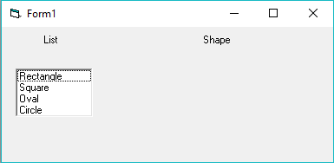

Before Clicking

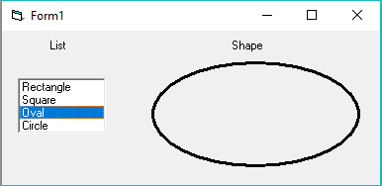

After Clicking

**Form Code:**

**For Form-1:**Private Sub Form_Load()  
List1.AddItem ("Rectangle")  
List1.AddItem ("Square")  
List1.AddItem ("Oval")  
List1.AddItem ("Circle")  
Shape1.Visible = False  
End Sub  
  
Private Sub List1_Click()  
Shape1.Visible = True  
If List1.ListIndex = 0 Then  
Shape1.Shape = 0  
ElseIf List1.ListIndex = 1 Then  
Shape1.Shape = 1  
ElseIf List1.ListIndex = 2 Then  
Shape1.Shape = 2  
ElseIf List1.ListIndex = 3 Then  
Shape1.Shape = 3  
End If  
End Sub

**Assignment-2**

**Problem Statement:** Create a ComboBox containing the following country names – a. India b.

England c. USA d. Bangladesh Write a programme in VB6 so that when a particular country is selected from the ComboBox its national flag will be displayed in the screen.

**Screen-Shot:**

**Form-1:**

Before Clicking

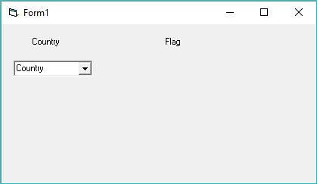

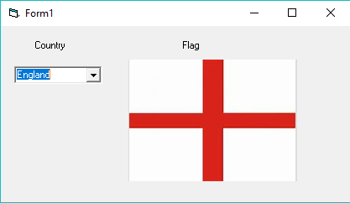

After Clicking

**Form Code:**

**For Form-1:**Private Sub Combo1_Click()  
If Combo1.ListIndex = 0 Then  
Image1.Picture = LoadPicture("C:\Users\Sayantan\Desktop\arnab\india.jpg")  
ElseIf Combo1.ListIndex = 1 Then  
Image1.Picture = LoadPicture("C:\Users\Sayantan\Desktop\arnab\england.jpg")  
ElseIf Combo1.ListIndex = 2 Then  
Image1.Picture = LoadPicture("C:\Users\Sayantan\Desktop\arnab\usa.jpg")  
ElseIf Combo1.ListIndex = 3 Then  
Image1.Picture = LoadPicture("C:\Users\Sayantan\Desktop\arnab\canada.jpg")  
End If  
End Sub  
  
Private Sub Form_Load()  
Combo1.AddItem ("India")  
Combo1.AddItem ("England")  
Combo1.AddItem ("USA")  
Combo1.AddItem ("Canada")  
End Sub

**Assignment-3**

**Problem Statement:** Create a splash screen application using timer and progress bar. The idea is

you have to create two form in VB6. When progress bar will reach its Max

value then first form will be closed and the second form will open.

**Screen-Shot:**

**Form-1:**

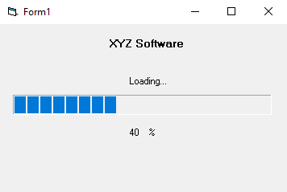

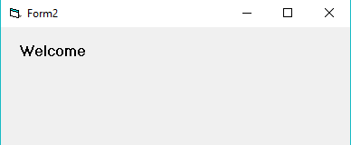 **Form-2:**

**Form Code:**

**For Form-1:**Private Sub Timer1_Timer()  
ProgressBar1.Value = ProgressBar1.Value + 5  
Label3.Caption = ProgressBar1.Value  
If ProgressBar1.Value = ProgressBar1.Max Then  
Timer1.Enabled = False  
Form2.Show  
Unload Me  
End If  
End Sub  
 **For Form-2:**Private Sub Form_Load()  
Label1.Caption = "Welcome"  
End Sub